RESUME
Hemant Kumar Singh  E-mail-hemantsshemant@gmail.com  Contact -8882453886  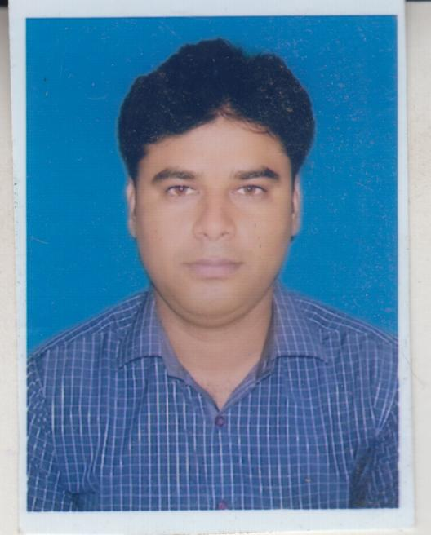  Communication address  B 67, vipin park godhkhor patia, Ankleshwer,393001 Bharuch, Gujarat  Permanent address  Vill- Ukaroura  Post- Hafizpur  Azamgarh,276001  Personal details  Father- Mr. Davbrat Singh  Mother- Nisha Singh  D.O.B- 28/02/1992  Languge – Hindi, English | Objective  - Looking for suitable position as a Professional to contribute value to the growth of the Organization and build skills in a professionally managed and satisfying environment.  Experience  - I am having 7 months of experience in Hydrogination plant.  - Currently working as an Production & Plant Supervisor in AMARJYOT CHEMICAL LTD (GROUP OF AARTI INDUSTRIES LTD), Jhagdia, Gujarat.  - It is manufacturing DYES INTERMIDIATES PRODUCTS.  - Capable to operation and controlling of Distributed controller system (DCS).  - Handling solvents like Diethyl ketone, toluene and methyl ketone.  - Equipment handled: HYDROLISER REACTOR, VACUUM DISTILLATION COLOUM, HEAT EXCHANGER, VACCUME PUMP and PISTION PUMPS DRYER.  Education  - M.tech(Chemical Engineering) from GGSIPU Dwarka, New Delhi with 74.23% in 2016.  - B.tech(Chemical Engineering) from Noida Institute of Engineering & Technology Greater Noida(UPTU) with 68.2% in 2013.  - Higher secondary from Children Higher Secondry School(U.P Board) Azamgarh with 69.6% in 2008.  - Matriculation from Children Higher Secondary School(U.P Board) Azamgarh with 63.7% in 2006.

ACADMIC PROJECT

M.tech project
Title : Removal of dyes from wastewater using Natural adsorbents.
Tenure : 1 year(During M.tech final year)
B.tech project
Title : production of biodesel from waste ediable oil.
Tenure : 6 months(During B.tech 8th semester)

PUBLICATION
- Hemant singh, Garima Chauhan, Arinjay K. Jain, S.K.Sharma, adsorptive potenstial of agriculture wastes for removal of dyes from aqueous solution, journal of environmental chemical engineering, 5, 2017,122-135.
CONFERENCE
- Singh H., Chauhan G., Jain A.K., (2016) “color removal from synthetic dye sample using bio adsorbent” 2nd International conference on “Recent advance in bio-energy research(ICRABR)”, oral presentation, Karpurthala, Panjab(February 25-27,2016).
SEMINAR
- Attended seminar on “Material of construction for chemical process plant organizes” by IICHE(NCR).
TRAINING
- 1 month traning in Indian Khaitan chemical & fertilizer limited(KCFL), Somani Unit, Rajnandgaow, Chattisgarh.
- 1 month traning in Indian fertilizer Co-operative limited(IFFCO), Phulpur Unit, Allahabad.
TECHNICAL SKILLS
- UV Visible Spectrophotometer Analysis, Atomic Absorption Spectrophotometer, Scanning Electron Microscopy, Fourier Tranfer Infrared spectroscopy.
ACHIEVEMENTS
- I got Golden Jubilee Scholarship for the academic year 2015-2016 from Indian Institute of Chemical Engineers (IIChE).
- Head Coordinator in “NORTH ZONE INTER UNIVERSITY VOLLEY BALL (MEN) CHAMPIONSHIP 2015-16”.
- Event coordinator in Anugoonj 2016 at USCT, GGSIPU Dwarka New Delhi.

I hereby declare that the above mentioned particulars are true to the best of my knowledge and belief.
HEMANT KUMAR SINGH

